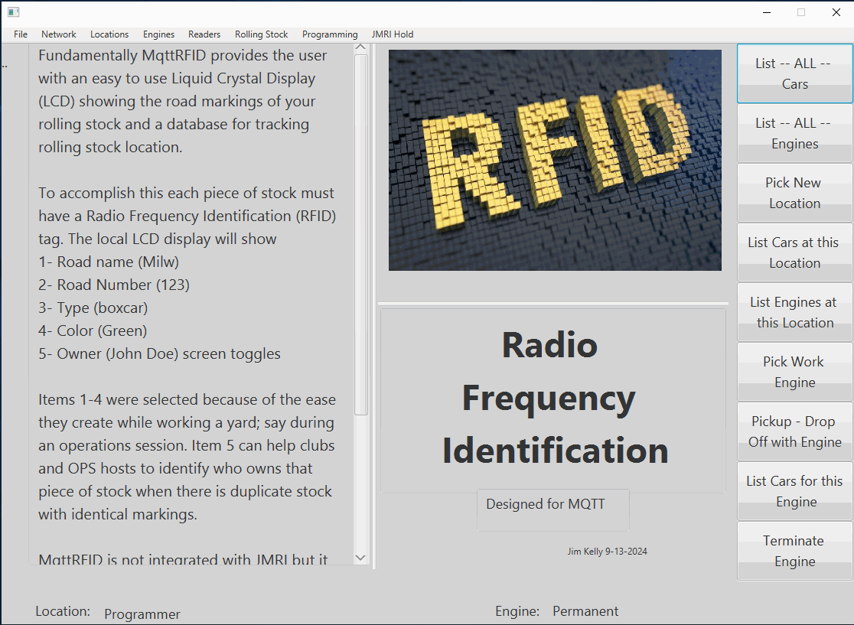

**SST Computers**

MqttRFID

Radio Frequency Identification

For Model Trains

User’s Manual

Version 1.0

# Summary

Fundamentally MqttRFID provides the user with an easy to use Liquid Crystal Display (LCD) showing the road markings of your rolling stock and a database for tracking rolling stock location.

To accomplish this each piece of stock must have a Radio Frequency Identification (RFID) tag. The local LCD display will show

1- Road name (Milw)

2- Road Number (123)

3- Type (boxcar)

4- Color (Green)

5- Owner (John Doe) screen toggles

Items 1-4 were selected because of the ease they create while working a yard; say during an operations session. Item 5 can help clubs and OPS hosts to identify who owns that piece of stock when there is duplicate stock with identical markings.

MqttRFID is not integrated with JMRI but it does have a 'hook' into its XML files so that if you have entered your engines, cars and locations that information can be pulled into MqttRFID and even send that information to a RFID chip without having to manually re-enter all that data. A small modification to these files is required; more details are explained later in this manual.

(The above text is displayed on the default main screen)

MqttRFID is written in Java and that means if you already have JMRI running it's a quick and easy install.

**Note: This program requires an installed MQTT broker.**

I designed it using the Mosquito broker which is available from the Internet. The program looks for the broker to be installed on the same machine (localhost) and it expects to find it at the default port address.

# Licensing

The software associated with this program is licensed under the MIT license and is available at https://github.com/jwkelly49/MqttRFID-for-Java-11/tree/master. The hardware (also available at github) is licensed under The TAPR Open Hardware License.

This software and hardware has been developed in the spirit of sharing the hobby of model railroading and my desire is to allow it to spread throughout the hobby as freely as possible. Basically, do what you want to with it, but you can’t prohibit others from doing the same thing, even your changes.

Copies of these licenses are available on my GitHub account.

# Downloading software

This program is written in Java version 11 (sometimes called 1.8) and therefore can be run on several different computer platforms.

https://github.com/jwkelly49/MqttRFID-for-Java-11/tree/master

You may download the MqttRFID.EXE file (for Windows) or the MqttRFID.zip (the JAR file) file for the computer; but you’ll also need to download the Arduino.zip file. The Windows EXE does the same thing as the JAR files (Windows users can even use the JAR file if they prefer.)

Create a new folder somewhere on your computer (i.e. C:\MqttRFID) and copy MqttRFID.exe into it. Or unzip MqttRFID.zip into it. Unzipping the file will create a subfolder call \lib and a JAR file called MqttRFID.jar. EXE users don’t worry when you run the exe file this will be done for you automatically.

You may want to create a “Shortcut” on your desktop at this point. When you run the EXE or JAR for the first time the program will create additional subfolders and files that you will never need to access; most notably a folder for the database and a configuration file.

# Program startup

This is a bit like the ‘Chicken or the egg’ question; which to do first. Should I energize the readers first and then start the program; or should I start the program and then turn on the readers? It really doesn’t matter either way it’s going to look like something is wrong. The program tests for a MQTT broker and the readers and the readers test for an available MQTT broker. So the secret is the MQTT broker. How you turn-on and shut-down your equipment is completely up to you; but expect something to be reporting a fault during start-up. I’ll illustrate what I think would be a typical start-up situation and you can adjust your expectation based on your experience.

1. Power up the computer. If you have the MQTT broker installed as a service (recommended) it will be ready to use. If you elect not to use it as a service, start the MQTT broker (see broker documentation for the how to’s.)

2. Start the MqttRFID program. The main window appears and in approximately 2 seconds a pop-up will appear showing you that the readers can’t be found.

3. Start-up your layout. As each reader powers up it will link to the network (details later) and look for the MQTT broker to connect too. Since you already have the broker running no fault will be shown on the LCD display. For reference a fault would say ‘No Broker Connection Established.”

4. Return to the program pop-up and click the ‘Query Network’ button. The software will then test for the readers and should update to display ‘System is good to go’ (details later.) Close the pop-up and have fun.

NOTE: New readers being added to the network require a small amount of configuration (details later.)

# Now the manual

The layout of this manual is centered on the menu structure and is augmented by YouTube videos if you prefer that approach.

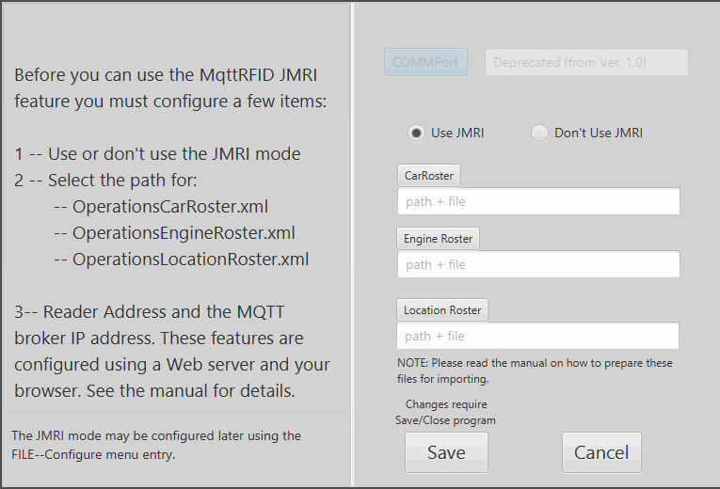This will be the first screen you see. At this point the program has configured the database and now needs to build the configuration file:

Will you be using the JMRI Option? -- You may choose to (Use JMRI) or (Don’t Use JMRI) This feature can be enabled later from the FILE menu.

If you choose to enable it now use the buttons to capture the PATH and file names of the three JMRI Operations files.

NOTE: Please read the “Importing from JMRI section of this manual” as you should be using COPIES of these files and not the originals.

Clicking Save will exit the program. Now restart the program to see the main screen.

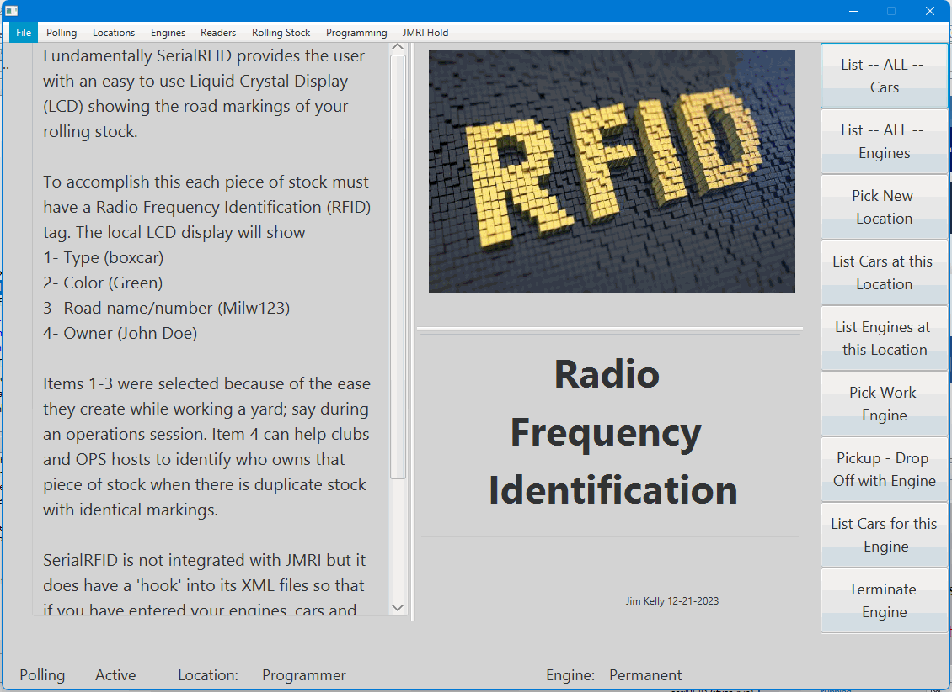The restart will open the main screen. At this point the program tests for a MQTT broker. If a broker connection can’t be established a small pop-up will tell you about the problem. Clicking the OK button will cause the program to close. The program will not proceed until a successful broker connection can be established.

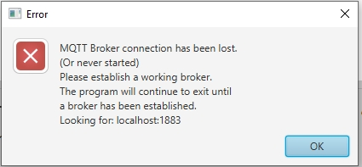

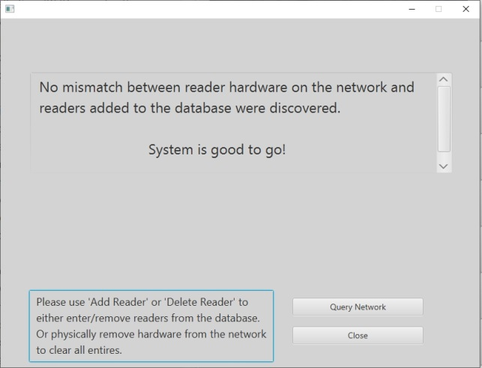Once a broker connection has been established the program will now test for the appropriate reader hardware. This opens one of two possible pop-ups.

Once you have established a working reader network you should see the simple ‘System is good to go!’ pop-up.

This pop-up indicates that the installed hardware (readers) and the database entries for installed readers match.

‘Close’ the pop-up and have fun -- no action required.

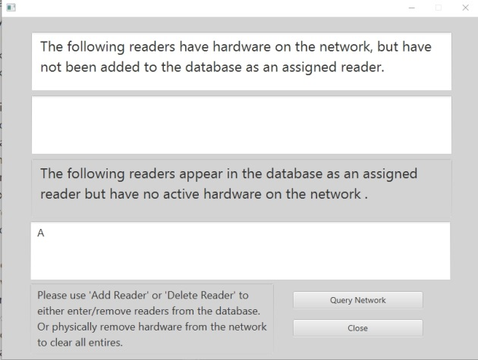

When adding a new reader or if a hardware device has a problem the second possible pop-up will be displayed.

The top half references the installed hardware -- If reader addresses appears here it most likely means that you are adding a new reader. Go to the ‘Readers’ menu and add it to the database.

The bottom half references the database entries -- If reader addresses appear here it can mean that you have lost the connection to a reader (hardware) or that the reader was deleted from the database for some reason. Troubleshoot the hardware or correct the database.

As you work to correct the network use the ‘Query Network’ button to re-test the network and refresh the screen.

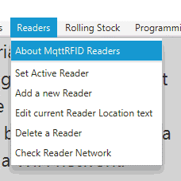

Once the program has confirmed the network at start-up it will continue to check the broker connection (background testing) but it will no longer query for readers. If during program use you wish to test the network this can be performed from the ‘Readers/Check Reader Network’ menu option.

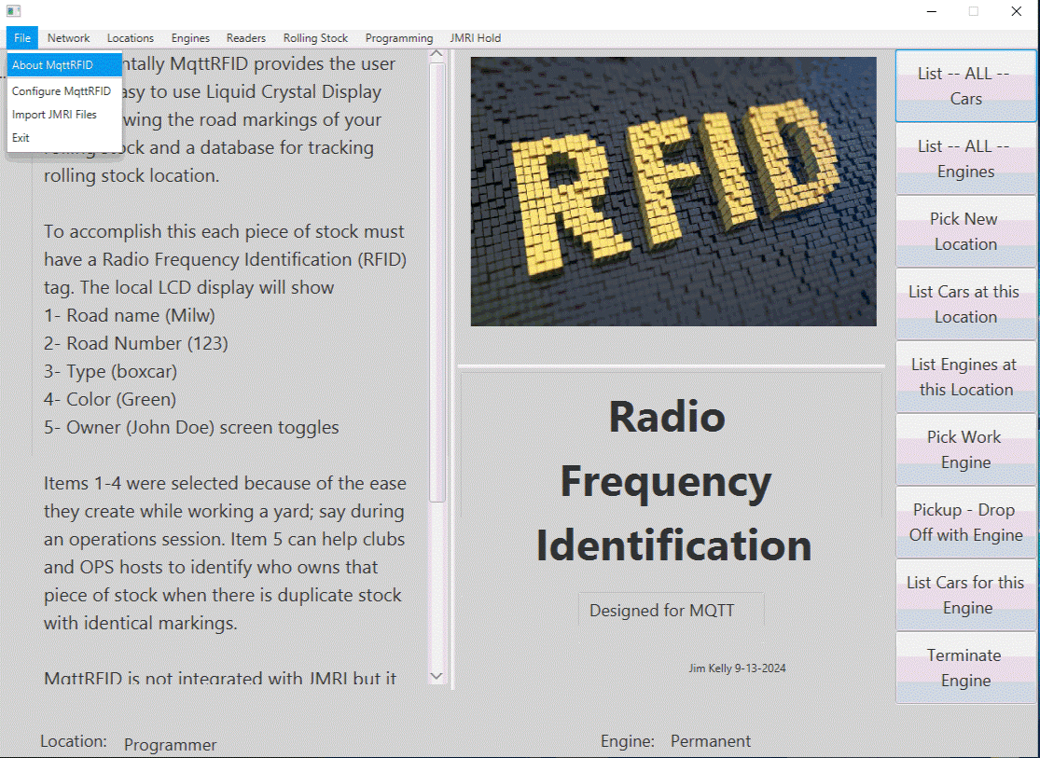This is the default main window which appears at program start-up.

Across the top of the window is the menu feature. Each menu item has an ‘About’ selection that provides a brief overview of what that menu deals with.

Shown here is the ‘About’ for the FILE menu selection. It provides a basic overview of the program.

Along the right-hand side are 9 nice big easy to click buttons. These are fast links to the most used menu selections. They are the most common functions and should speed up your workflow.

The bottom edge is the status line and will provide you with a quick reminder of which location and engine combination you’re currently using.

[Real world perspective]

*I ‘loosely’ view the computer as a yard master or as an administrator. Once you have entered your rolling stock most of the action will be happening at your layout local control panels. But when using the computer you must make an association between an ‘engine’ and a ‘location’ just like you do with a local control panel (more later.) The computer can only work with one engine and one location at a time.*

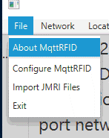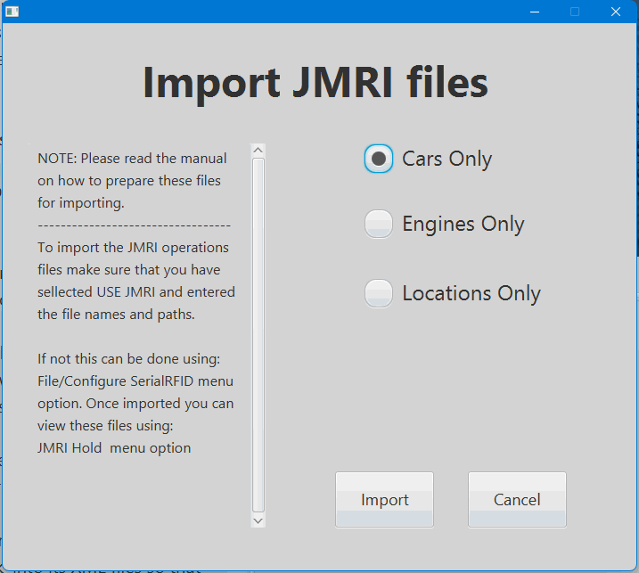Under the FILE menu you have 3 selections.

**Exit --**

Does exactly that and closes down the program.

**Configure MqttRFID --**

What Com port to use -- This was for SerialRFID Version 1.0 and has been deprecated for MqttRFID and replaced with: Reader Address and the MQTT broker IP address. These features are configured using a Web server and your browser (details later.)

Optionally -- You may choose to (Use JMRI) or (Don’t Use JMRI.) If you choose to enable this feature use the buttons to capture the PATH and file names of the three JMRI Operations files.

NOTE: Please read the “Importing from JMRI section of this manual” as you should be using COPIES of these files and not the originals.

**Import JMRI Files --**

If you have JMRI enabled this menu selection will be active. Be sure to read the section on using JMRI before importing because there is a small change needed in the XML files. Select the desired file(s) and click ‘Import’. There will be a slight pause as the XML file is moved into a MqttRFID database table. When complete a pop-up will tell you the number of records imported. If there is a problem the database will give you a pop-up explaining the issue and then will allow you to continue.

Clicking Save will force the program to close. When the program is restarted the new configuration will be active.

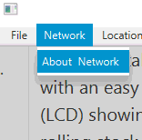 **Network:**

Network replaces SerialRFID Version 1.0’s Polling menu. And has only one feature

‘About Network’, this is an information/ introductory only screen.

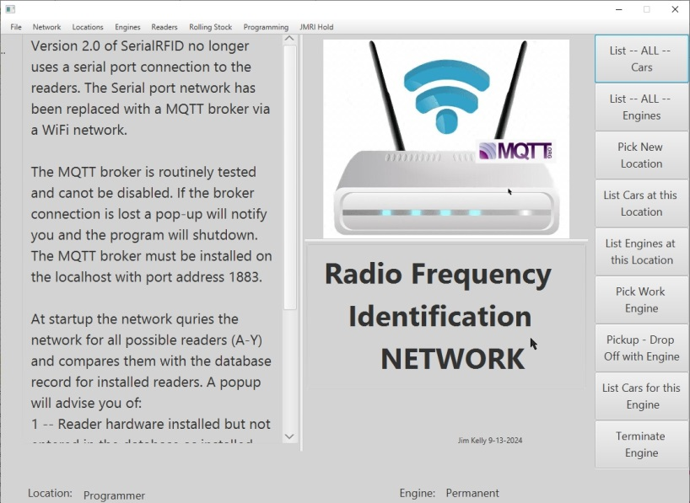

**About Network:**

Version 1.0 of MqttRFID no longer uses a serial port connection to the readers. The Serial port network has been replaced with a MQTT broker via a WiFi network.

The MQTT broker is routinely tested and canot be disabled. If the broker connection is lost a pop-up will notify you and the program will shut down.

The MQTT broker must be installed on the localhost with port address 1883.

At start-up the network queries the network for all possible readers (A-Y) and compares those with the database record for installed readers. A popup will advise you of:

1 -- Reader hardware installed but not entered in the database as installed.

2 -- Database entries for expected Readers for which no installed hardware can be found.

If the database and hardware match you will see a "Good to go" statement; close the popup and have fun.

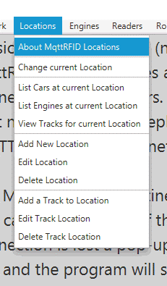

**Locations:**

About MqttRFID Locations: (screen not shown) MqttRFID requires at least reader 'A' be installed to be meaningful at all. As a result a permanent location (Programmer) and track (Programming Track) are also provided (though you can change the names.) Locations can be as simple as a list of readers referred to by address; or given textual names.

Locations may be imported from JMRI or you may manually enter your own names. Think of Locations as major layout divisions i.e. yards, cities or industrial zones.

JMRI also provides subdivision of locations into 'tracks.' MqttRFID therefore makes provisions for them as well. Think of tracks as smaller layout areas i.e. business siding or an individual track within a yard.

Tracks will NOT have their own readers (it would then become a location) but can be displayed from the Locations menu for reference purposes.

[Real world perspective]

*As I developed this program I had to view it from two perspectives hardware (readers) and operations (locations) but the truth is a reader* ***IS*** *a location; so the words are synonymous. Having developed the hardware first I wrote code from that perspective and later when I shifted my view I simply used the same code. Therefore under the ‘Locations’ menu you will see some items with the ‘Readers’ label. Some users may never use the ‘Readers’ menu while others, like me, may shift perspective while working with the hardware.*

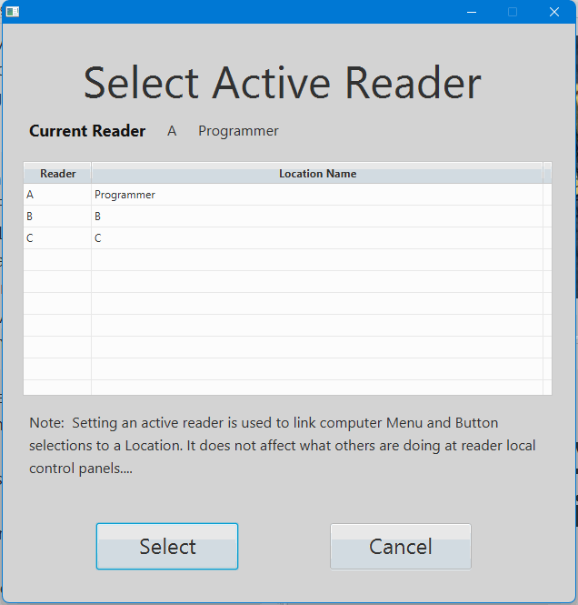**Change current Location** -- (AKA Select Active Reader)

As readers (locations) are installed they are added to this table. The user may now ‘Select’ one from the list. The computer database is now filtered to work with only rolling stock at this location.

List Cars / List Engines / View Tracks -- are read-only tables displaying information about the selected location.

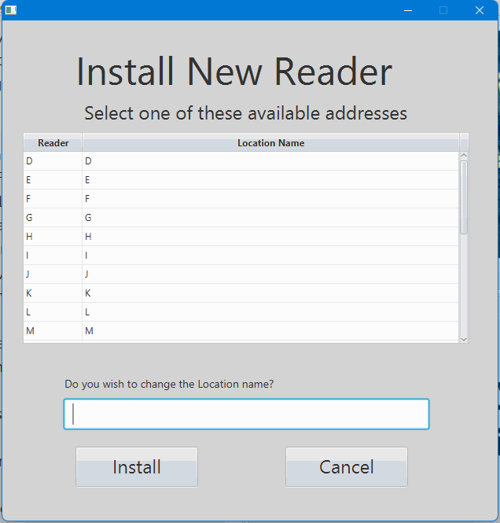**Add new Location** -- (AKA Install New Reader)

The database comes preloaded with all legal reader addresses (A-Y) and the location name by default is set the same as its address. As readers are installed they are removed from this list.

The user may choose to change the name at this time or later using the ‘Edit Location’ menu item.

Note: You may wish to use ‘Readers/Check Reader Network’ for the status of this reader.

Delete Location -- The user will be presented with a similar pop-up displaying all installed readers. Deleted readers will be added back to the ‘Add new Location’ listing for reuse later.

Note: Rolling stock currently assigned to the deleted reader (Location) will be orphaned in the database. It is recommended to move stock before deleting a location. Orphaned stock can be retrieved by reinstalling the Location (hardware not needed.)

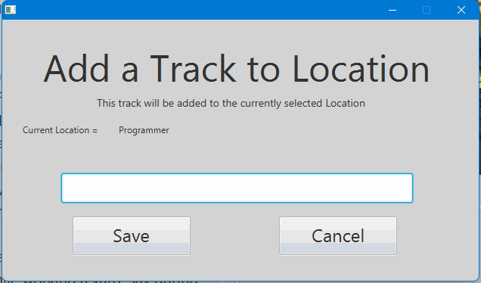**Add a Track to Location --**

Tracks are not locations and do not have a reader. They are text only entries in the database associated with a given location. They were added because JMRI uses them and having them in MqttRFID was nice just as a reference.

If you wish to use them without JMRI imports enter them here.

Edit Track Location / Delete Track Location update the database.

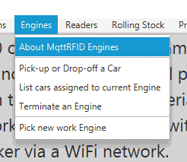**Engines:**

**About MqttRFID Engines:** (screen not shown) Out-of-the-box MqttRFID comes with a permanently installed engine called PERMANENT. This ensures the program can be started with this engine assigned to the default location (Programmer.)

MqttRFID uses the term engines to avoid conflict with JMRI Trains. Engines are used to move cars between readers so they can be dropped at a reader (i.e. location) or pulled from a location and added to an engine for movement to a new location. This is normally done at a reader's local control panel. At the computer they are added to the program as more of a maintenance function (i.e. clean up after an operations session.) Engines get 'assigned' to a location and work it 'pulling' or 'dropping' cars according to a manifest.

Are you in a hurry? Make a RFID card an engine place it on the reader (to assign it) then roll the car onto the reader and 'pull' it to the card. Now five finger airlift the car to the new location 'assign the card' and place your car on the reader to 'drop' it at this location.

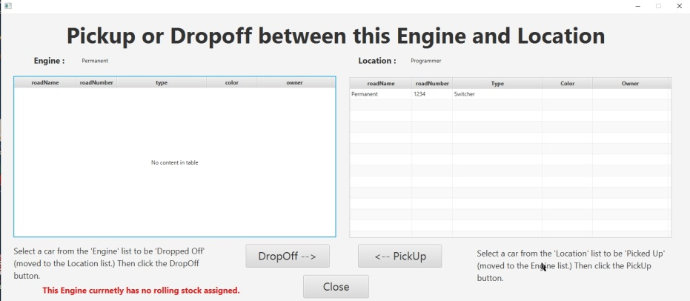

**Pick-up or Drop-off a Car --**

This is the meat and potatoes of the program.

On the left is the ‘Engine’ table listing all the rolling stock it is dragging.

On the right is the ‘Location’ table listing all rolling stock it contains.

To pick-up (or pull) a car from this location; go to the location table and click on that car’s listing. Then press the ‘PickUp’ button and watch as that entry is cleared from the location table and placed into the engine table. Dropping off a car is just as simple; click the desired entry in the engine table and press the ‘DropOff’ and watch it appear in the location table.

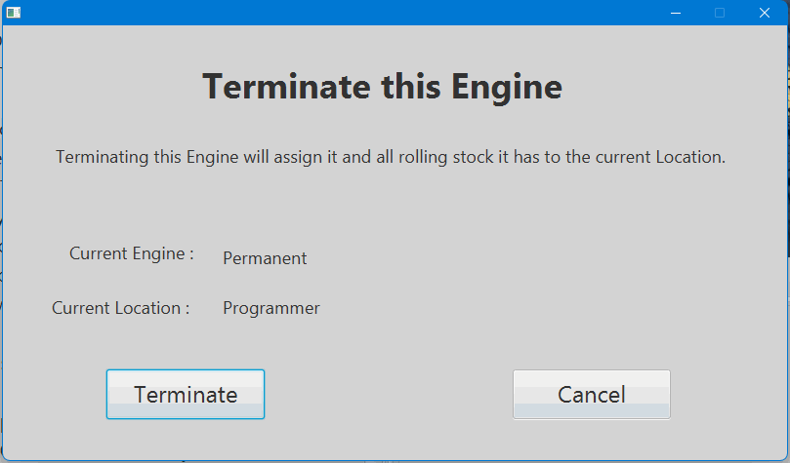

**Terminate an Engine --**

Has an engine reached its final destination? Then terminating it will dissolve it as an entity. The engine and all the rolling stock it was dragging will be placed into the location database. The next time this engine is selected for use it will have no rolling stock assigned to it.

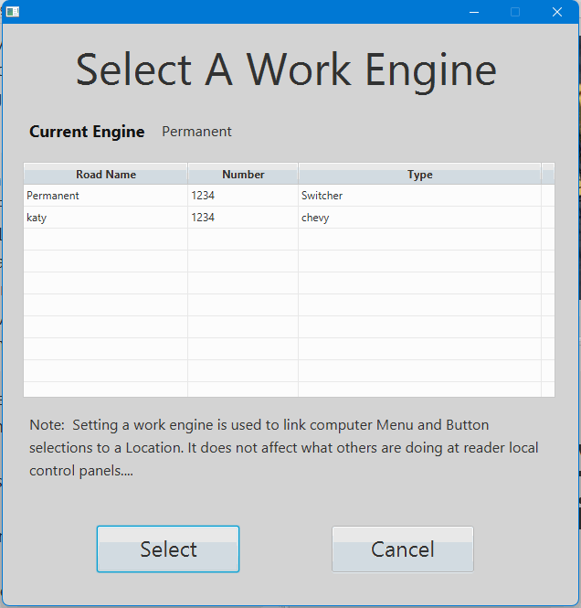**Pick new work Engine --**

As engines are entered into the system they will be placed into the engines table for selection.

This is one of the two menus (Change current Location) used to form a working link between an Engine and a Location. The selected engine (and location) will update the status line at the bottom of the main screen. This pair is used by the ‘Pick-up or Drop-off a Car’ menu selection.

**Readers --**

**About MqttRFID Readers:** Readers are the heart and soul of the program and it's why you use the program at all, so the requirement of at least one reader should be self-evident. The program must have a reader 'A' and since this is the minimum amount of readers required all write operations to a RFID tag are performed only to this reader.

Local Panel Switch usage:

Assign -- To properly transfer cars between an Engine and a Location the program must know which engine is at which location. Place the Engine on the reader and toggle the 'assign' switch. Now the Location and Engine are linked. In normal operations sessions multiple cars will be 'picked' and 'dropped' at a location. Once an Engine has been assigned to a Location it remains assigned until the assign switch is used again. ALWAYS assign the Engine before working a location or the cars will be transferred to the last assigned Engine.

Pickup -- (Also called Pull or Pulled) The computer will transfer the car record from the current Location and attach it to the Engine for movement to another Location.

Release -- Once the reader has detected a car it is ‘locked’ to that tag preventing a constant hunt for a tag. When a car has been successfully ‘Picked’ or ‘Dropped’ you must release the reader so it can be used by the next car. If an error is reported the car must be released from the reader so that it can look for the car again.

Drop -- The Computer will transfer the car record from the Engine and attach it to the current Location.

Green LED -- (On) A solid green means that the reader has discovered a new car over the reader.

Red LED -- (On) a solid red means an error has occurred. Remove the car and reposition it for a green LED.

By default the Arduino code will assign the address 'A' to all readers. When a new reader is powered up it needs to gain access to the network so it creates a Web server. Look on your computer for available networks and choose "New Reader." Enter the capital letter address (A-Y) for this reader and the IP address for the MQTT broker. The address of Z is reserved for system use.

**Check Reader Network:** This feature is described on page (4) Program Start up and page (5).

The remaining menu items are listed for those who are viewing the program from a hardware perspective. They are the same screens used in the ‘Location’ menu group, please revisit that group for details.

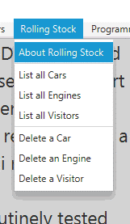

**Rolling Stock --**

**About Rolling Stock:**

The Rolling Stock menu is your equipment inventory tool.

The database is divided into two sections.

1 -- Permanent (your stock)

2 -- Visitors, club members or guests that have brought stock to run on the layout.

It provides a read-only selection for viewing all cars and engines.

It also allows you to permanently remove equipment from the program database. (i.e. visitors took their stock home.) There is no restore feature. To return a car or engine to the inventory will require using the program's 'programming' features.

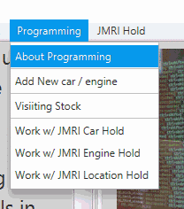

**About Programming:** Here is where the rubber meets the road (or the wheel meets the rail.)

This is where the computer interfaces with the field device called Reader ‘A’. Reader ‘A’ is unique among all the readers as it is the only one that the computer will use to program your radio frequency (RF) tags.

**Basics:** A car with a new RFID tag is placed on reader 'A'. The user fills in the data on the computer screen and it is sent to reader 'A' and recorded on the new tag. Then reader 'A' sends back the tag RFID identification number. The tag ID and car information are then stored in a MqttRFID database.

The Liquid Crystal Display (LCD) will show all rows filled with dashes (-) when a new tag is present. Upon a successful write to the tag the LCD will be updated to show the data entered from the computer. If a write operation should fail the LCD will display all rows filled with question marks (?).

**Visitors:** Sometimes guests will bring their own rolling stock (with a RFID tag) to run on your layout or you have new stock (with a RFID tag) to enter permanently into the database. Use the visitor form to enter this stock. Be sure to indicate if it is a 'Car" or 'Engine' and if it is a 'Visitor' (for inventory tracking) or 'Permanent' entry to the database.

*** FAILED WRITES ***

Failed writes have several variables to consider and experience will be your best guide to a solution.

RF Tag -- The smaller the tag the small its antenna will be, requiring it to be closer to the reader to capture enough signal strength for proper operation.

Distance -- Always try to place the RF tag as close to the reader as possible.

Metal -- Metal is the enemy of RF tags, some of your rolling stock may require tags designed for use in a heavy metal environment.

Tags I have successfully tested

Typical use -

https://www.abcrfid.com/product/13-56mhz-mifare-classic-1ks50-wet-inlay-thin-tag-adhesive-sticker/?wmc-currency=USD&country=US&gad_source=4&gclid=Cj0KCQjwztOwBhD7ARIsAPDKnkAl6-PpUNTnKLIESZAzKA_0eEMY0LPWaxt8g7R8GT8BpTIE272-d5UaAsMlEALw_wcB

Metal use -

https://www.ebay.com/itm/171977503338?chn=ps&mkevt=1&mkcid=28&srsltid=AfmBOorDm57GBIFJs8v4HnmvgTEClwjHiR-IxAUsOxMVrSeshjunGB-WKTM&com_cvv=d30042528f072ba8a22b19c81250437cd47a2f30330f0ed03551c4efdaf3409e

**Caution:**

Make sure you purchase the right frequency tags 13.56 mhz

Make sure they are Mifare Classic compatible (1k or 4k)

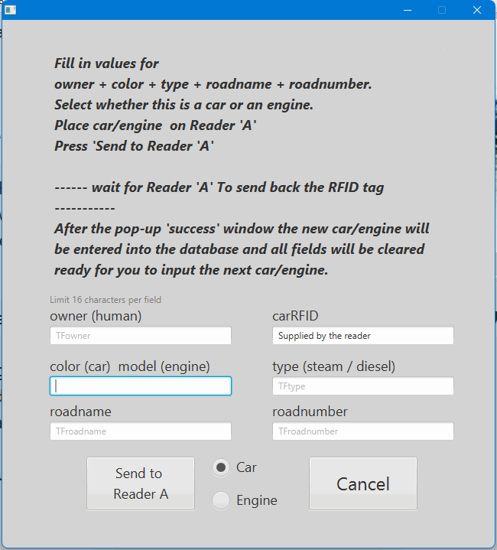**Add New Car/Engine:**

The same form is used to process ‘Car’ and ‘Engine’ so be sure you make the proper radio button selection.

Because of the RF tag design each entry will be limited to 16 characters. Spaces are permitted but try to avoid special characters to keep the database happy. If you really want them try the escape character (\) but it will cost you one character.

Owner -- The name of the person (or club) that owns this piece of rolling stock.

Color -- This field has two functions. For cars enter its color and for engines enter its model.

Type -- For cars enter things like box car or tank car or caboose. For engines enter steam or diesel.

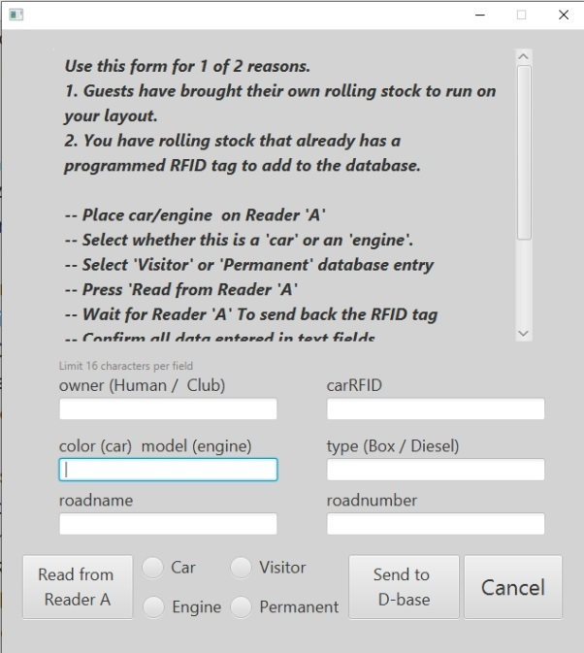

**Visiting Stock:**

The visiting stock form does many things in reverse of the ‘Add New Car/Engine’ form. Using the ‘Read from Reader A’ button it gets the tag information from the tag and fills in the form.

Select Car/Engine and Visitor/Permanent radio buttons.

Fill in the owner’s name

Press ‘Send to D-base’ and the visitor is entered into the database.

Work w/ JMRI menus -- These are explained in the JMRI section.

**Importing from JMRI** (optional)

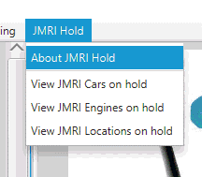Let’s start with an overview of the entire process before hitting the details. Assuming you elected not to use JMRI when you first installed the software go to the FILE menu and select the configure MqttRFID option. Select ‘Use JMRI’ and enter the three path and file locations for the temporary JMRI operations XML files. Restart the program. From the FILE menu choose ‘Import JMRI Files’ and import the three temporary files. These files are now entered into holding databases. You may now view these entries using the ‘JMRI Hold’ menus. A delete button is provided so that individual pieces of rolling stock can be removed before starting the actual imports. From the ‘Programming’ menu you will now find the ‘Work w/ JMRI’ options are available. Select an option Cars/Engines/locations. For cars and engines pick one from the table and you will be presented with the programming form shown above. The difference is that the fields will automatically be filled with the exception of the ‘Owner’. Supply the owner’s name and click ‘Send to reader A’. With each successful import the stock will be removed from the hold database and placed into the working database.

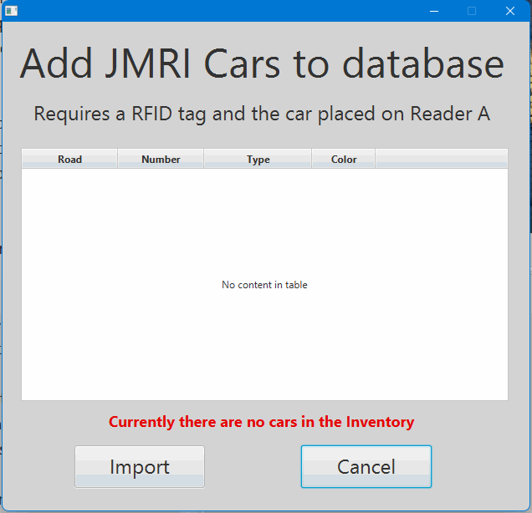

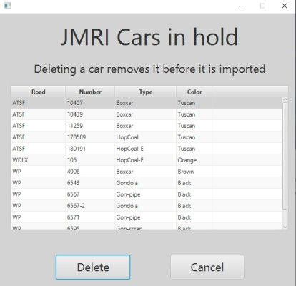

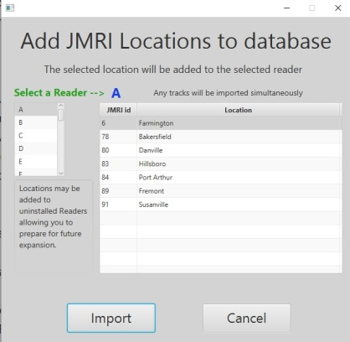When adding locations you must pick a JMRI location from the table and a reader from the list box on the left. The selected reader is shown in blue. Any tracks that JMRI has for that location will also be imported at the same time.

**Preparing the JMRI XML Files**

Please make copies of the three JMRI Operations files (OperationsCarRoster.xml, OperationsEngineRoster.xml, OperationsLocationRoster.xml) and place them in a convenient place like your desktop (they can be deleted when you are finished.)

A small change must be made in each of these files (hopefully I will eliminate this in the next release.) NotePad or any text editor will work fine for making these changes.

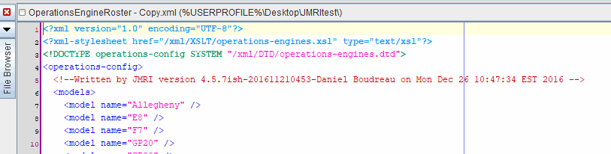Shown here as line 3

<!DOCTYPE operations-config SYSTEM …..>

This whole line needs to be deleted and the file saved.

Repeat this for all three files and these temporary files are the ones you enter on the configuration screen.

**Configuring the Readers (Hardware)**

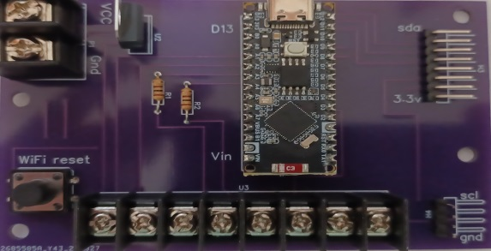There are two hardware buttons on a reader. The small white button on the Arduino is the program reset button and has nothing to do with configuring the hardware.

On the board is a larger button (usually black), this is the network configuration button.

Out-of-the-box the Reader will always fail to connect to a network and must be configured to match your network. For any other reason (like changing the Reader address) use the ‘Config Button’. You must press and hold it for a minimum of three (3) seconds. Once the configuration mode is activated the reader will reboot and the LCD screen will indicate that the reader is in ‘Config Mode.’

**NOTE:** Don’t try to rush things; you are working with the network router, the layout computer and the Reader hardware. The software involved for this operation has Latency by design that you can do little to affect.

Once the LCD indicates the Reader is in Config Mode perform the following steps:

1. Go to the layout computer (where MqttRFID software is installed.)
2. Depending on the Operating System you’re using find - ALL available networks. On Windows this is usually in the lower right hand corner with the famous radio signal Icon.
3. Open the list and wait (usually) until you see a network named NEW READER.
4. Click on this network and connect (No password required), things begin to slowly happen.
   1. The layout computer drops off of the normal network -- (loss of Internet reports)
   2. Your Web Browser will open (if closed) and a new tab will link to the Web Server running on the Reader Hardware. (Faster if you already have the browser open.)
   3. A WiFiManager Menu will be displayed. Select ‘Configure WiFi’ (Probably the only option you’ll ever use.) (See pictures below)
   4. The Reader Web Server will populate the browser with a list of all available networks. Click the appropriate ‘normal’ network and it will fill in the SSID text box.
   5. Enter the password for your normal network connection.
   6. Below the password text field will be two (2) parameters fields.
   7. Reader Address: This is a Capital A - Y. (Defaults to A) Type in the desired address for this reader.
   8. Broker IP address: This must be in the form of xxx.xxx.xxx.xxx and not the ‘Computer Name’ or ‘LocalHost’. (Defaults to 10.0.0.13) Type in the correct IP address for your MQTT broker. (This is the same IP address as the layout computer.)
   9. Press ‘SAVE’ and wait. Monitor the Layout computer’s list of all networks and see that it gets reconnected back to your normal network. Most likely the NEW READER network will still be displayed (latency) but will disappear with time.
   10. The Reader should now be on your normal layout network (Each reader gets a random name if you try to look them up. I never bothered to look.)
   11. You can now start up the MqttRFID software and the network testing should detect the new reader. If the program was already running go to the Readers menu and select the check network option.
   12. Hardware found? Go to the Readers menu and use the Add New Reader option and select the same address you gave to this reader.
   13. Refresh the ‘Check Network’ screen and it should say ‘System good to go!’
   14. The Reader will permanently store this information and automatically connect to your normal network every time you power it up.
5. Helpful Hints
   1. Never power up more than one (1) new Reader at a time.
   2. I found the simplest thing to do if a Reader fails to connect properly is to power it down and wait for the NEW READER network to disappear from the ‘All networks available list.’ Then start all over again.
   3. Clicking the ‘connect’ on the NEW READER network too many times just aggravates any problem.
   4. Be patient remember this is a one-time setup and won’t be necessary every time you use the program.

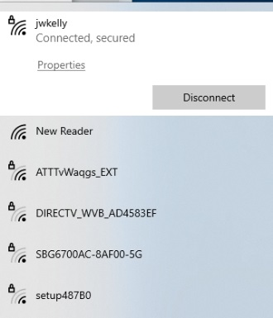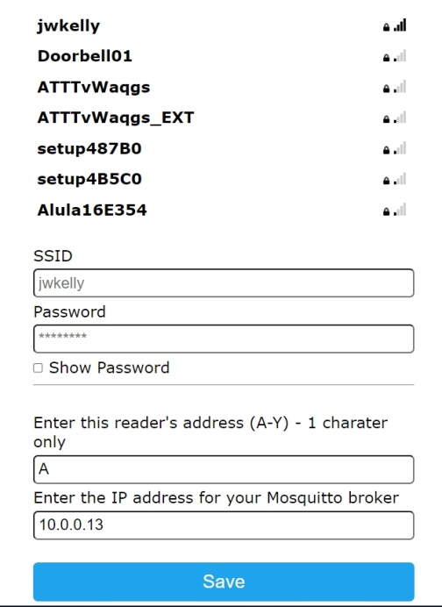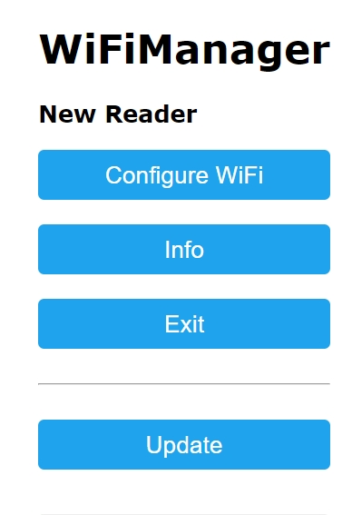

**The Hardware**

I am going to rely on you visiting my GitHub site and watching the YouTube hardware video. This is where you can download the information for the printed circuit board too.

https://github.com/jwkelly49/MqttRFID-for-Java-11/tree/master